Figure captions.

Fig. 1. Arthropod biomass (total grams per branch) with pooled comparisons between native plants and each invasive plant species. Biomass is reported as total wet mass collected from branches. Mean ± SEM is plotted, with levels of significance illustrated for native versus each invasive plant species using grouped, planned contrasts.

Fig. 2. Effect size of bird exclusion treatment showing pooled comparisons between native plants and each invasive plant species. Bird exclusion effect size reported as Log-Response Ratios (LRR), in which positive values > 0 indicate a significant reduction in arthropod abundance in response to bird predation. Mean ± SEM is plotted, with levels of significance illustrated for natives versus invasive plant species using grouped, planned contrasts.

Fig. 3. Total % nitrogen for insect herbivores on bird-exclusion branches. Nitrogen content is measured as the total molecular mass of elemental nitrogen relative to total mass of a single sample from an experimental host-plant branch. Mean ± SEM is plotted, with levels of significance illustrated for natives versus invasive plant species using grouped, planned contrasts.

Fig. 4. Total % nitrogen for true spiders on bird-exclusion branches. Nitrogen content is measured as the total molecular mass of elemental nitrogen relative to total mass of a single sample from an experimental host-plant branch. Mean ± SEM is plotted, with levels of significance illustrated for natives versus invasive plant species using grouped, planned contrasts.

Fig. 1.

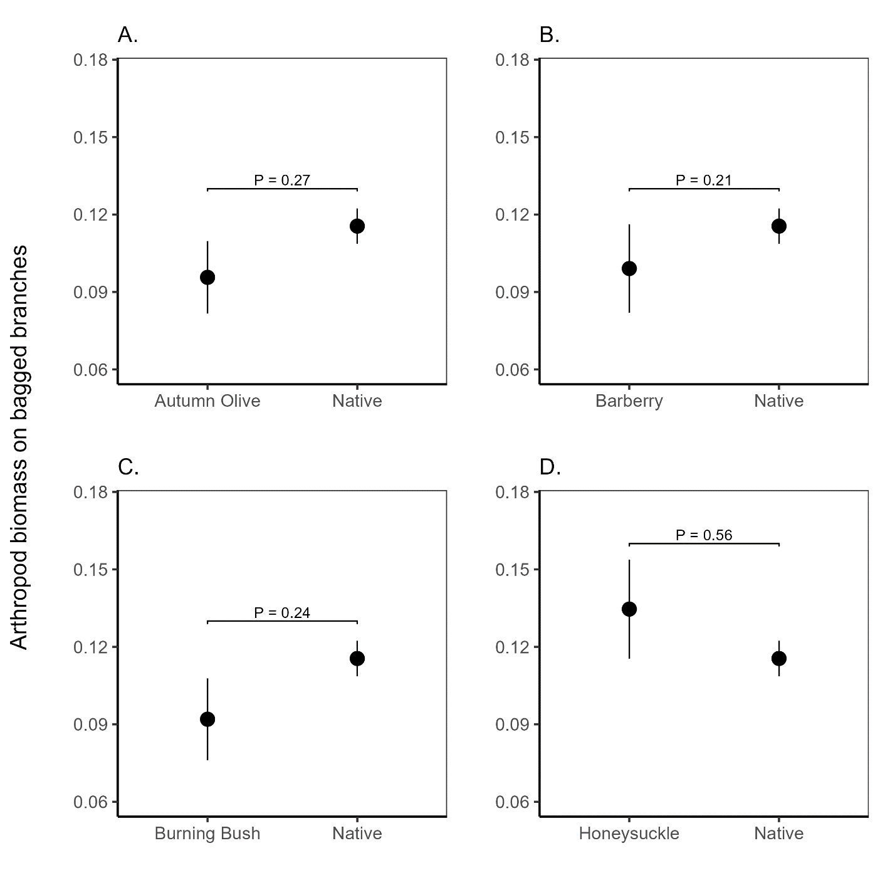

Fig 2.

Fig 3.

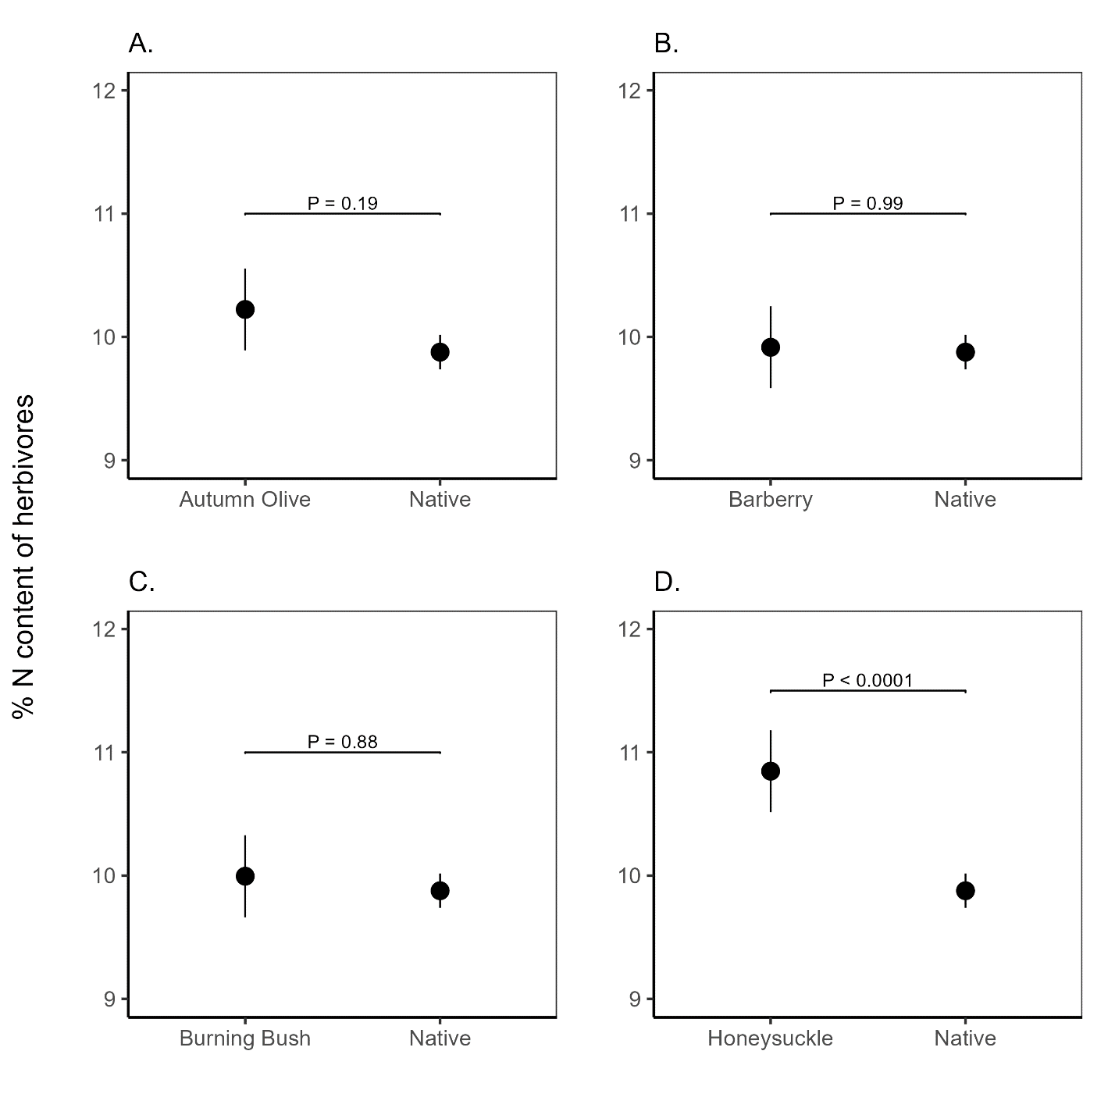

Fig 4.

